**Animesh Parab T2-T21 88**

**ASSIGNMENT-8**

**AIM:-**To understand continuous monitoring using Nagios

**LO MAPPED:- LO1, LO5**

**THEORY:-**

Nagios is an open-source monitoring system that provides monitoring of services, applications, and network resources. It is designed to alert system administrators about potential issues before they become critical problems. Nagios allows you to monitor the entire IT infrastructure, including servers, switches, applications, and services. It provides a comprehensive monitoring solution for both small and large organizations. Some key features and capabilities of Nagios include:

**Monitoring Capabilities:** Nagios can monitor a wide variety of network services including SMTP, POP3, HTTP, NNTP, ICMP, SNMP, FTP, SSH, and many more.

**Alerting and Notification:** It provides alerting and notification functionalities to notify system administrators when something goes wrong. Nagios can send alerts via email, SMS, or other methods to ensure that the right people are notified in real-time.

**Plugin Architecture:** Nagios has a modular architecture that allows users to develop their plugins and addons to monitor specific devices and services that are not covered by default.

**Customizable Dashboards and Reports:** Nagios offers customizable dashboards and reporting capabilities that provide insights into the performance and health of the monitored resources.

**Scalability and Flexibility:** Nagios can scale to monitor complex, large-scale IT infrastructures. It is highly flexible and can be customized to meet specific monitoring and alerting requirements.

**Extensibility:** Nagios can be extended through various addons and plugins, allowing it to integrate with other tools and services, and enabling the monitoring of a wide range of devices and applications.

**Historical Monitoring and Trend Analysis:** Nagios can store historical data and provide trend analysis, allowing system administrators to identify patterns and plan for future infrastructure needs.

**Community Support and Active Development:** Being an open-source project, Nagios has a vibrant community that contributes to its development and support. This community-driven approach ensures that the software remains updated and robust.

**Centralized Monitoring:** Nagios provides a centralized view of the entire IT infrastructure, allowing administrators to have a comprehensive overview of the health and performance of all monitored resources from a single location.

**Integration with Third-Party Tools:** Nagios can integrate with various third-party tools and services, making it a versatile monitoring solution that can fit into different IT ecosystems and workflows.

**STEPS:-**

1) **Go to google.com, Search Nagios Demo**

**Click on the first link shown below**

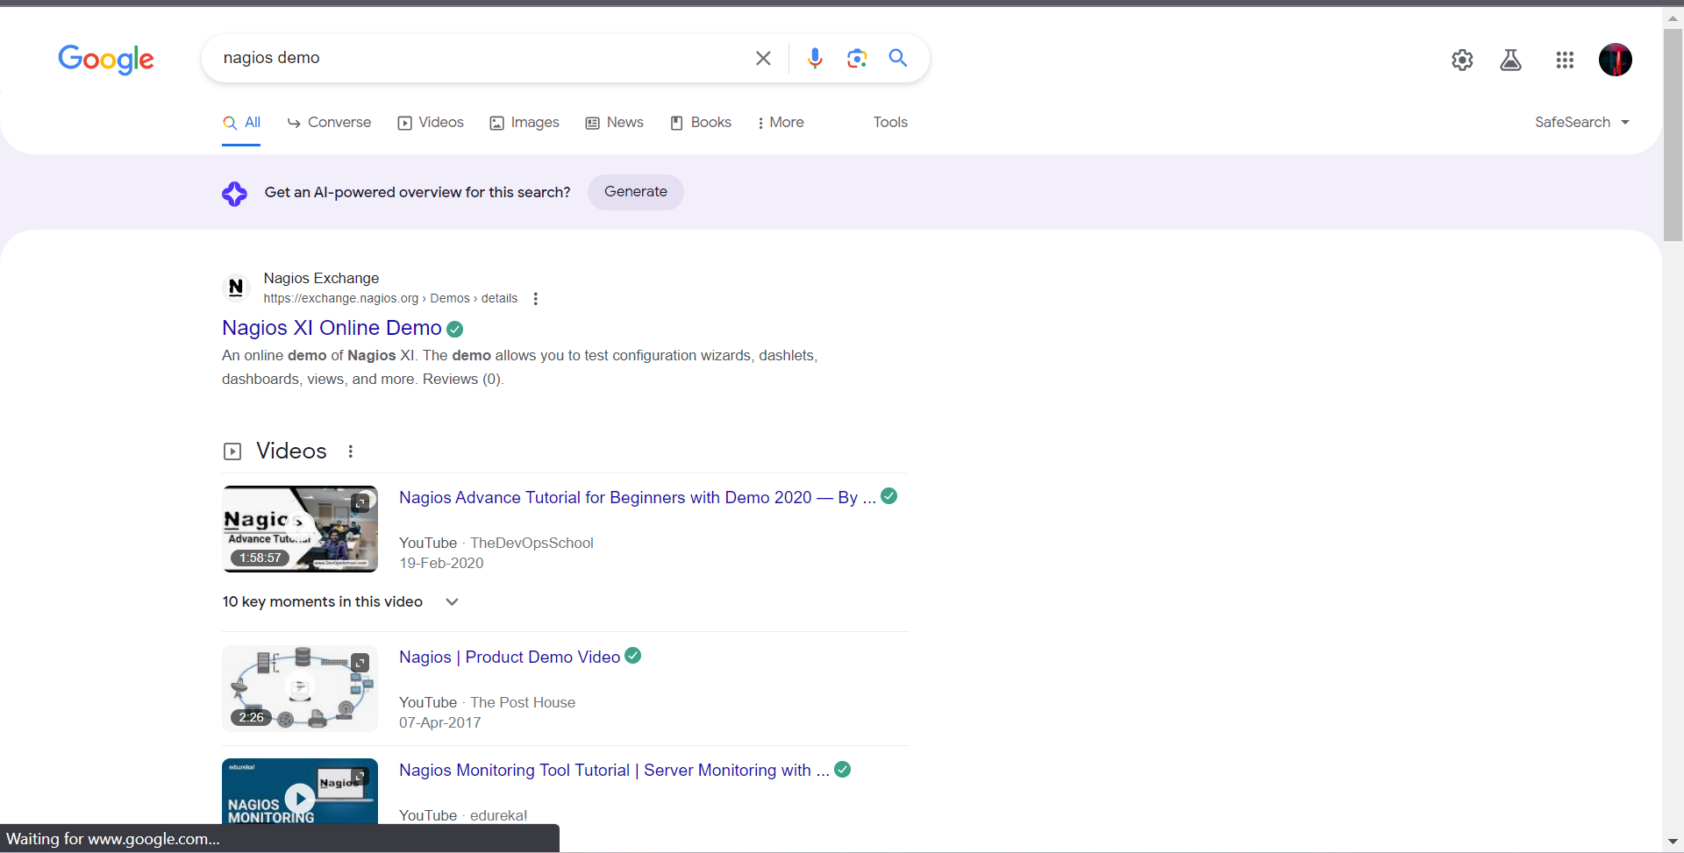

**2) Now click on the website-**

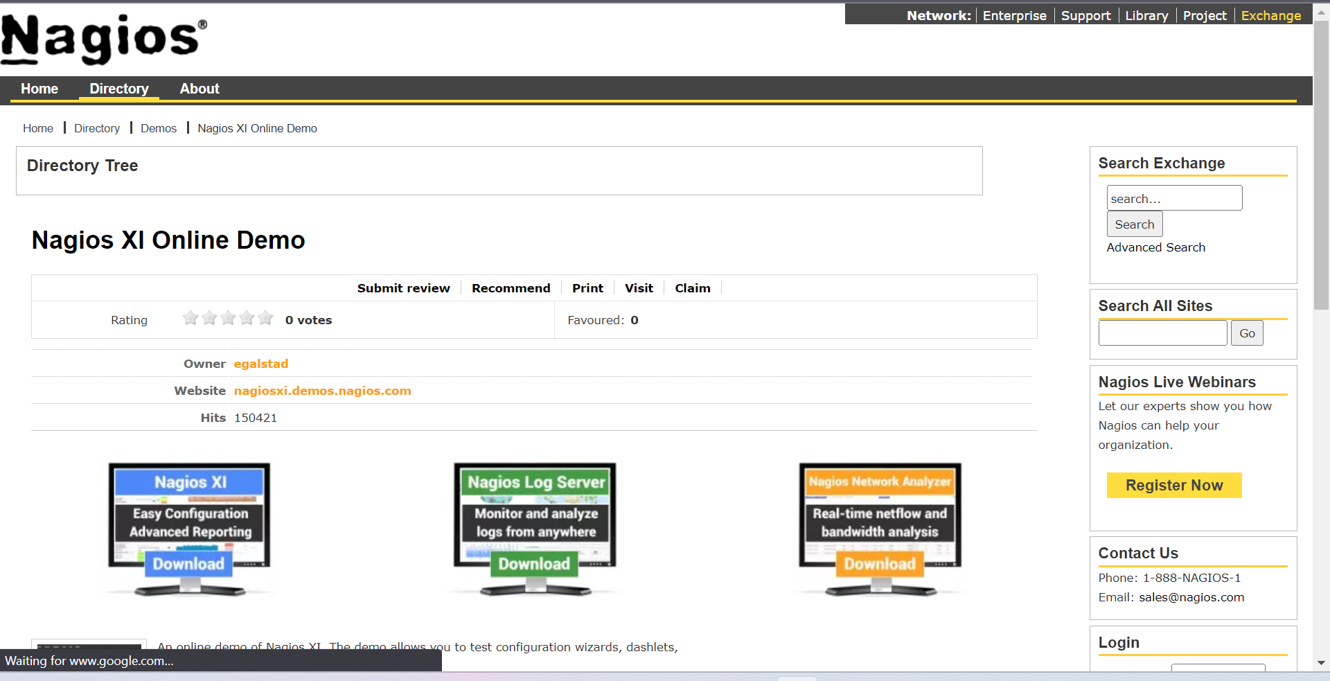

**3) Now click on login as administrator**

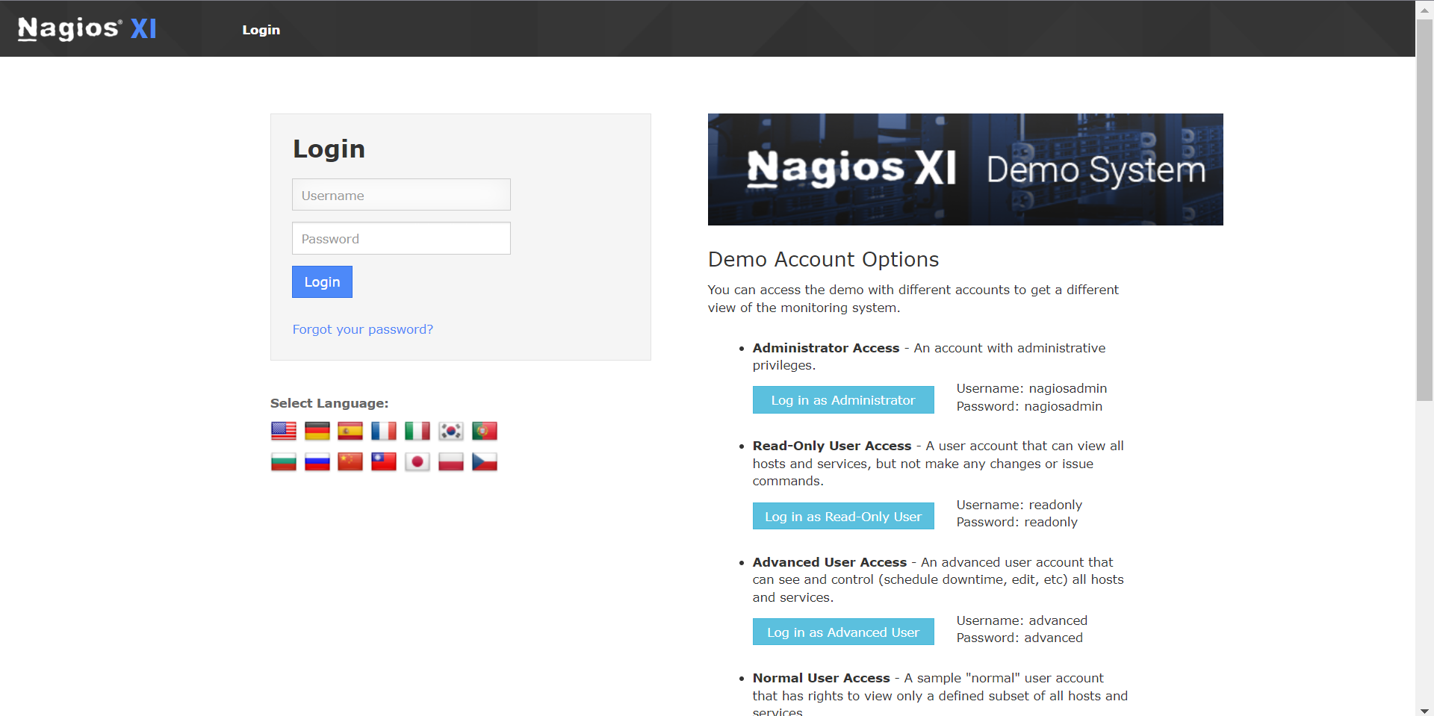

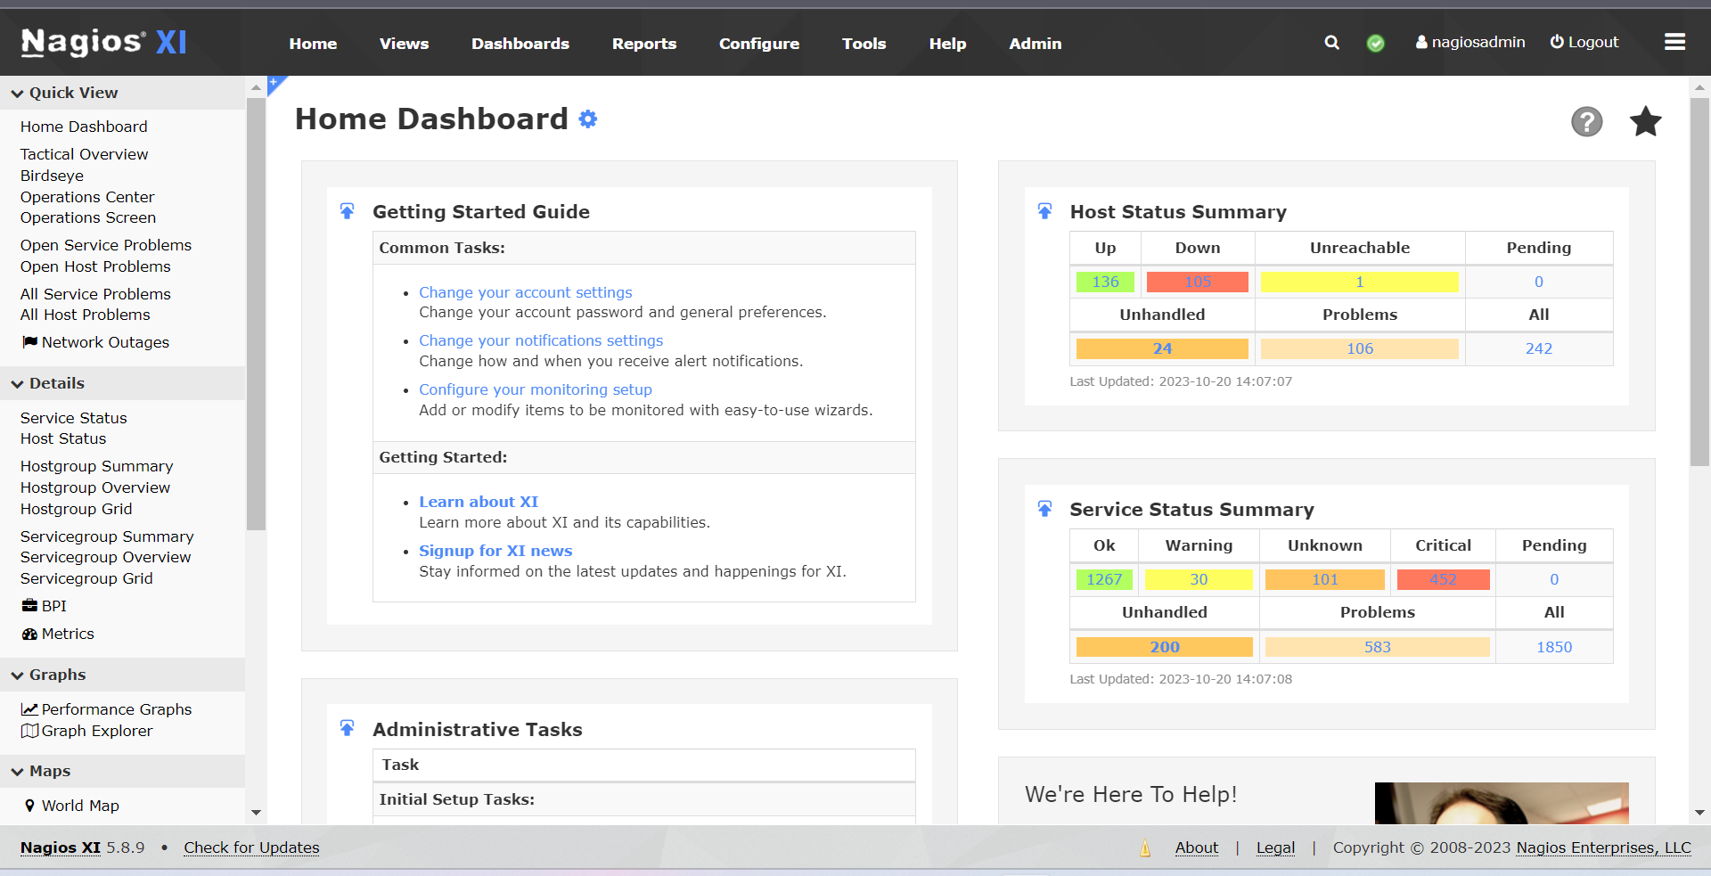

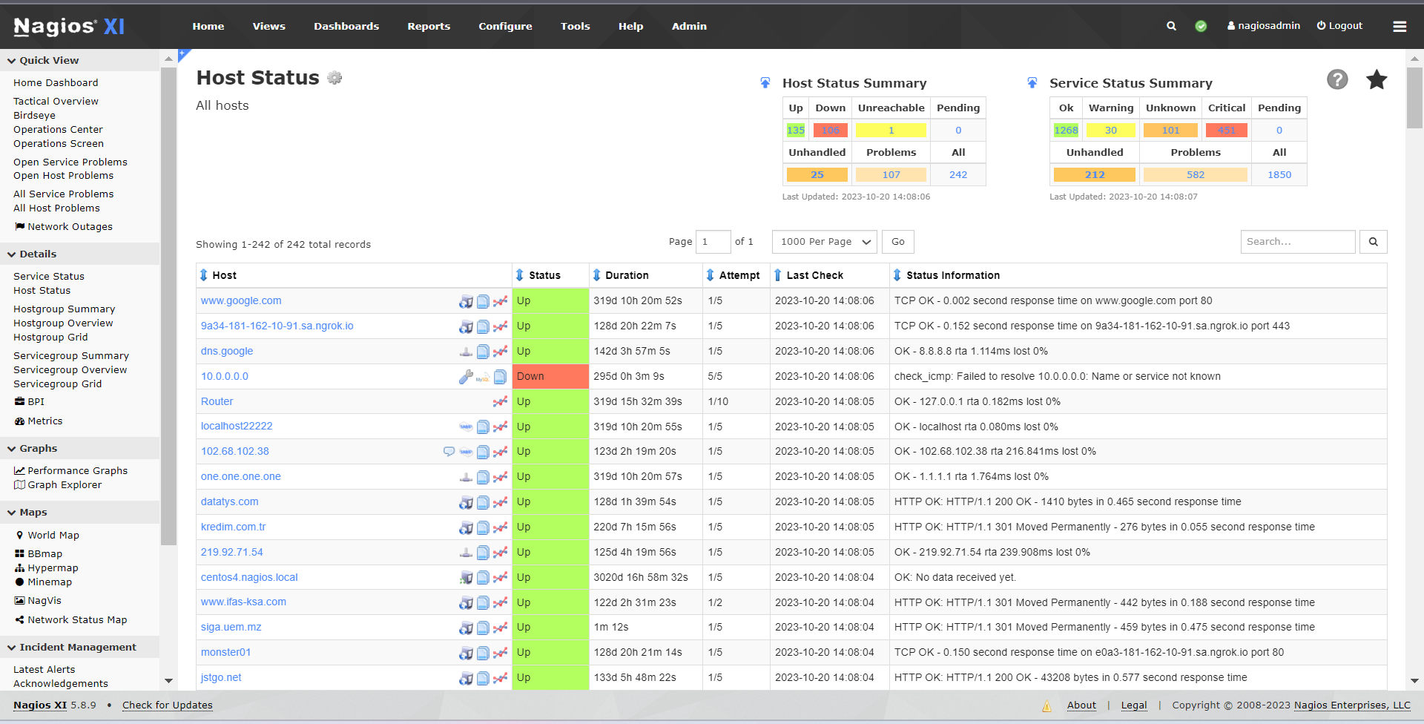

**In the above image one can see Host Status Summary and Service Status Summary also how many host are up, down and also errors in detail**

**5) Now click on Host Group Status.** 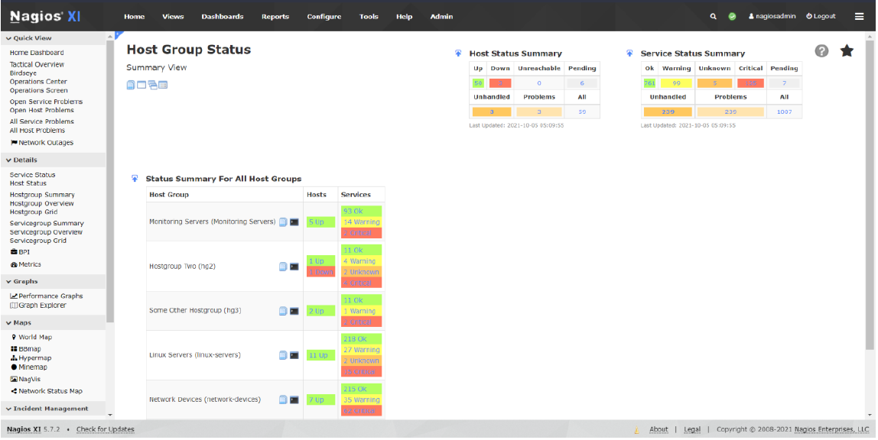

**6) Now we click on BBMap**

**In this we can see status of following stuff in each host-**

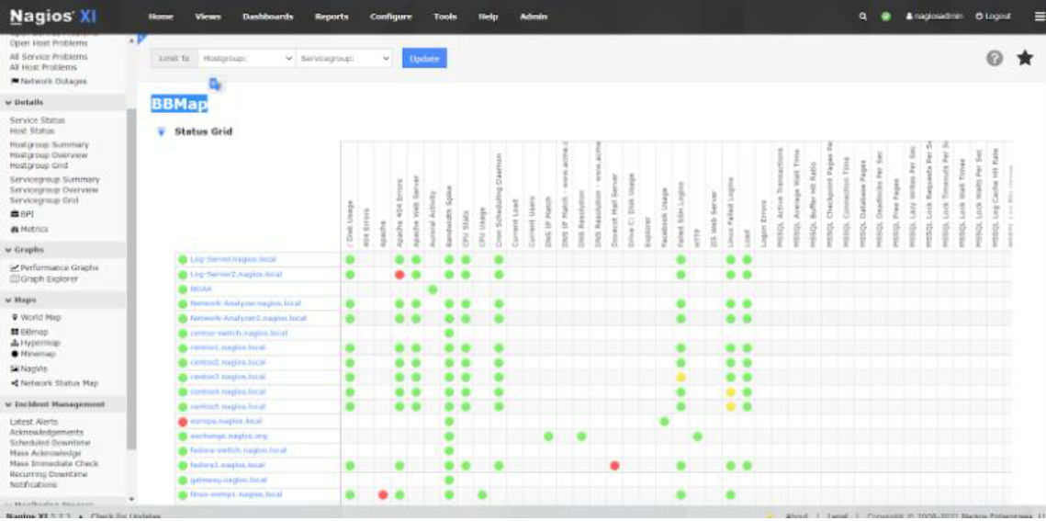

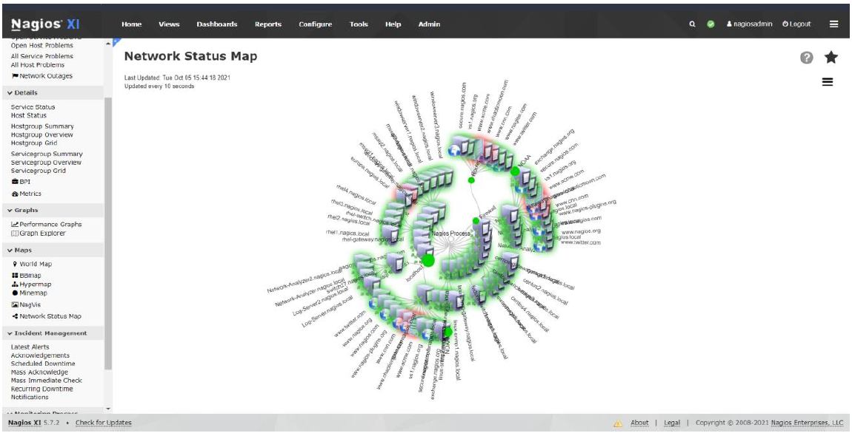

**CONCLUSION:-**

Continuous monitoring with Nagios enables proactive detection of system issues, ensuring minimal downtime and enhanced operational efficiency. Through customizable alerts and comprehensive reporting, Nagios empowers administrators to maintain optimal performance across diverse IT environments. Its scalable architecture and robust community support make it an invaluable tool for streamlined and centralized monitoring.